Name_____________________________________ Period_______
Last year when you studied The Odyssey, your teachers talked extensively about archetypes. Please remember that an archetype is a pattern or model of character, symbol, motif, situation, or theme that is universally present in human psyche, and therefore occurs repeatedly throughout literature across eras and cultures.
Your task is to complete a sort of “Deconstructed SAR” by filling in the table in complete sentences.
Archetype | Example from other literature/film/media and why. | Example from  Of Mice and Men and why (in a nutshell) | Evidence to support your assertion (quote/tight paraphrase) | Explanation of how textual citation supports your assertion
Wise Fool - A character who is mentally inferior, but able to reveal the best and worst of others. | In Night, Moishe the Beadle is written off by most people as speaking nonsense, but he truly warned the people of Sighet about the coming horrors of the Holocaust.
Everyman - A normal, average fellow who is neither exceptional nor terrible. He is relatable because he symbolizes the difficulty of challenging through everyday life. |  | George could be categorized as the everyman because…
Hero - This character, in his wisdom or strength, seems larger than life. He can be a leader or a king. | You first encountered this archetype with Odysseus, known as brave, strong, and clever in the Odyssey.
Temptress/Unfaithful Wife - A temptress is a beautiful woman who brings destruction for the man she seduces, usually the hero. An unfaithful wife is a married woman involved in illicit affairs. | Speaking of the Odyssey, this can also relate to Calypso, Circe, and the Sirens, all of whom distract Odysseus from his journey with their assorted charms.
Outcast - This character type is one who is banished
Unhealable wound – this is something that may be physical or psychological
Water – a symbol of life and birth and baptism. |  | The pool by the grove is where the story starts and ends with new beginnings and endings.
Haven versus Wilderness – Havens are places of safety and comfort, whereas the wilderness includes any place of danger.

Another topic you studied extensively last year was that of character foils. A foil is another character who is structurally similar, but contrasts in a significant way in order to highlight a certain characteristic.
Pick a pair of characters who are foils for one another in Of Mice and Men and compare and contrast them below. There are only 2 stipulations:
- You may not use Lennie and George as your pair. (You may use either one of them in contrast with a different character.)
- You must support all assertions with examples from the text.

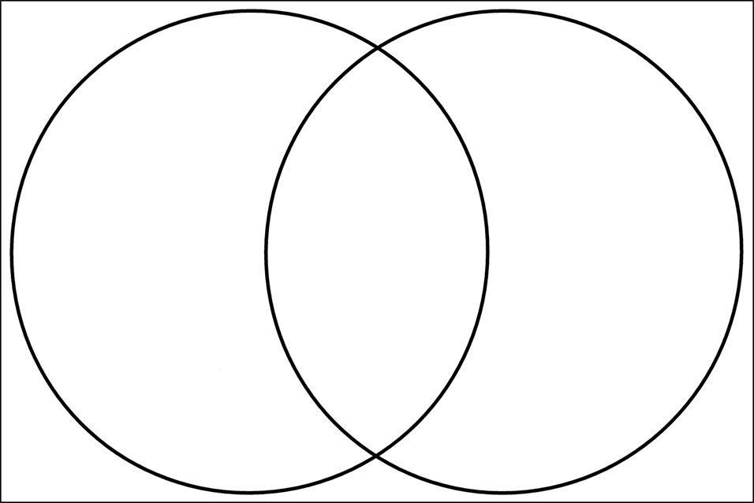

- 1.

2. 2.

3. 3.

